# Q.1) Write a Python program to count the even, odd numbers in a given array of integers using Lambda.
lis = [10,34,44,5,67,87,92,23,87]
list_even=[]
list_odd=[]
for i in lis:
if i % 2 == 0:
list_even.append(i)
else:
list_odd.append(i)
print(lis)
print(f"count of even numbers: {len(list_even)}")
print(f"count of odd numbers: {len(list_odd)}")
list1 = [21,43,534,63,23,64,32,64,51,73]
even = len(list(filter(lambda x: x % 2 == 0, list1)))
odd = len(list(filter(lambda x: x % 2 != 0, list1)))
print("array : ", list1)
print("number of even count :", even)
print("number of odd count :", odd)

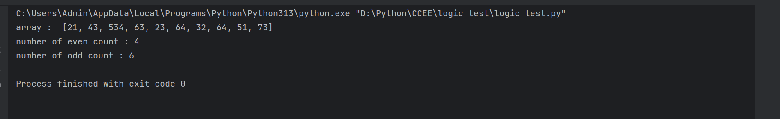

# Q.2) Write a Python program to find palindromes in a given list of strings using Lambda.
words = ["madam", "crispy", "nigga", "stupid", "racecar"]
palindrome = list(filter(lambda x: x == x[::-1], words))
print(palindrome)
print(words)

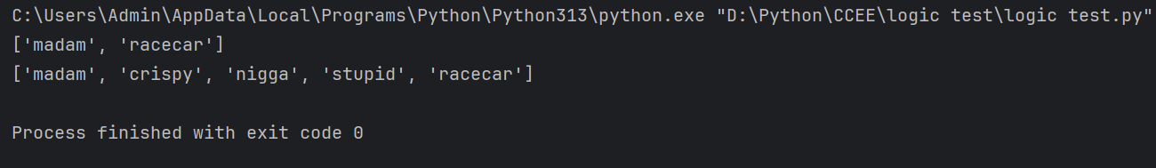
# Q.3) Solve the following pattern using one loop only: accept no. of rows from user.
"""
1
121
12321
1234321"""
rows = 4
for i in range(1, rows+1):
for j in range(1, i+1):
print(j, end="")
# print i-1 to 1
for j in range(i-1, 0, -1):
print(j, end="")
print()

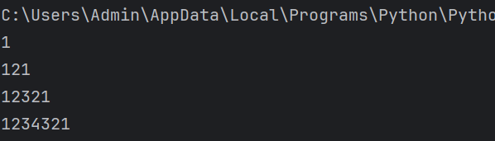
"""
Q.4) Write a Python program to convert a byte string to a list of integers.
Sample Input:
“hello”
Sample Output:
[104, 101, 108, 108, 111]"""
drip = "hello"
b = drip.encode()
result = list(b)
print(result)

